**Habits on Metallica**

In this project, I have tried to analyze my data of Spotify. In this year, it shows that I have listened to Metallica for more than 40.000 minutes. I know that it looks extremely high, but I can say that it was enjoyable. In my data I use the benefits of my huge fandom and created new visualized results about Metallica. The results were pretty fine and unique in my opinion.

**My Hypothesis**

It may be an agreement that I am a huge fan of Metallica. However, there is a term “poser”, you might hear, which means that listening to a song or band or behaving like a fan of something just in order to get attention. This term is used to put hate on popular things. Shortly it is a product popular culture haters. These haters think that popular things- movies, series, games, songs and more- are bad, just because they are so popular. Well, when you see the reason of them being bad, it already looks a ridiculous thought. In my project I have aimed to show that popular things have a huge chance to be good, and that is why they are so popular. In Metallica field, there are some highly popular albums that are listened by mainstream, like Black Album, and there are some thrash metal albums which are listened by hard metal fans, such as Ride The Lightning. So Black Album listeners are considered as poser in this school of thought. Since I am a huge fan and no “poser” would listen to Metallica for about 45.000 minutes in a year, I can be a worthwhile example for that. During the whole year, songs my listening habits were purified from these types of biases and I have listened at my own sweet will. At the end, it will be seen how much I have listened mainstream songs, and thrash metal songs. My purpose is to show that even though something is an element of popular culture, that does not mean it is bad.

**Process on Data**

Maybe it was most struggling part for me to analyze data. But, for sure, I have really enjoyed it. I requested my personal data from Spotify and waited for a few days to collect it.

First problem was to split albums to genres that I have created to make a separation between poser and hard fan. Since songs in my data was made of only artist, song name, date, and milliseconds played, I needed to teach the album and song information to computer. I coded every album and their songs to compiler.

metin, ekran görüntüsü, yazı tipi içeren bir resim

Açıklama otomatik olarak oluşturuldu metin, ekran görüntüsü, yazı tipi, doküman, belge içeren bir resim

Açıklama otomatik olarak oluşturuldu

After this process I enter the information of genres for albums and read the data of Spotify. Not only albums, I have also tried to detect which concerts I have listened more, bassists areas, emotion of music and more. If you want more detailed information about that you should take a look at PowerPoint presentation.

Unfortunately, there was a problem about a concert. This is Symphonic Concerts with San Francisco Symphony, the problem is that there is no information about these concerts in songs’ names, so I decided to code them by hand.

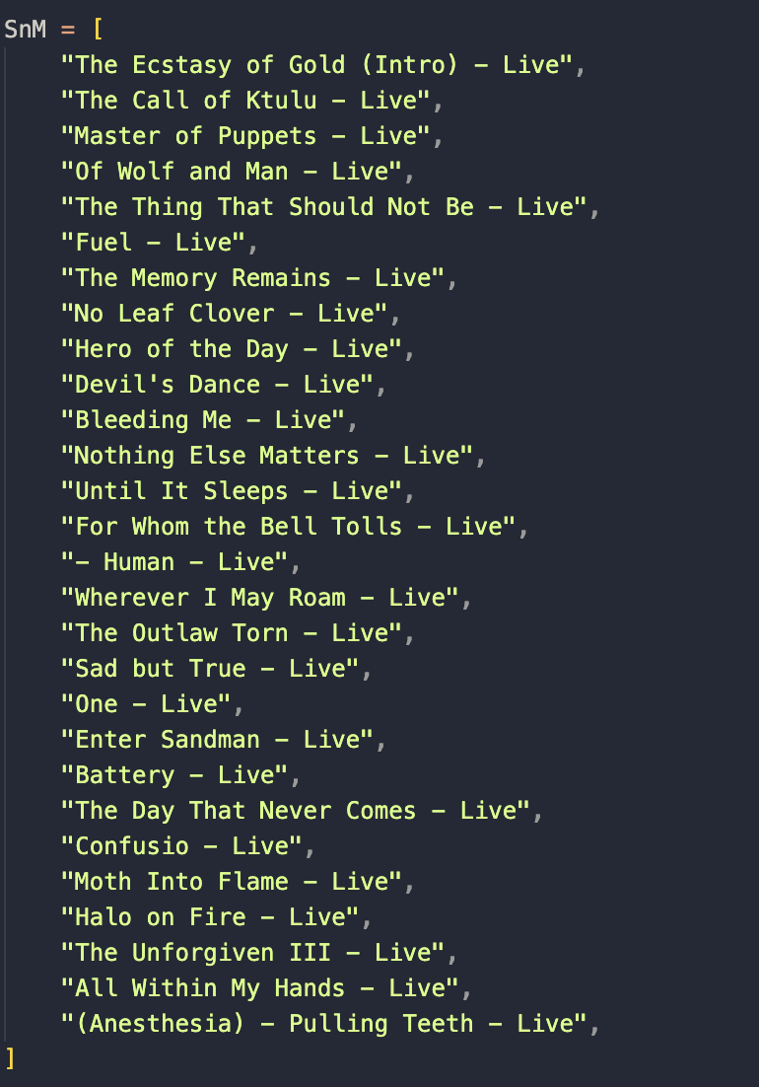

Shortly these were some specific problems about my data besides the syntax and algorithm problems. It had a sweet challenge vibe according to me.

**Results, Hypothesis and Song Suggester Machine Learning Algorithm**

My favorite product is a machine learning algorithm that I have studied on, it gives a suggestion for next song. But before that, we should check other results to understand it better. Firstly, I analyzed my most listened albums, I found the separation of genre that I have listened. I also analyzed the eras of three different bassists as well.

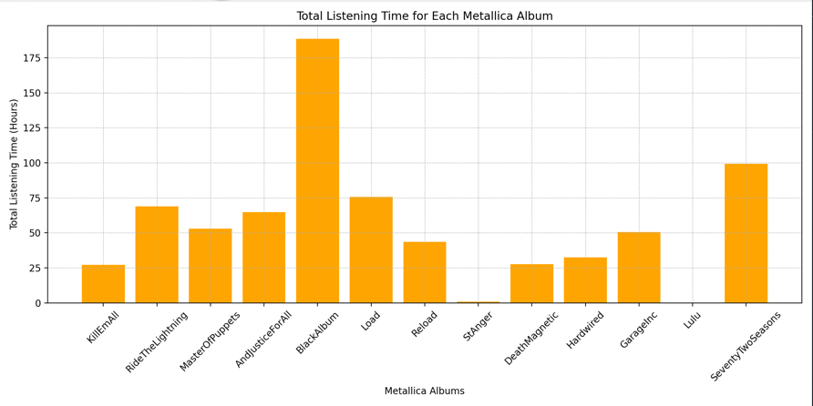

metin, ekran görüntüsü, diyagram, yazı tipi içeren bir resim

Açıklama otomatik olarak oluşturuldu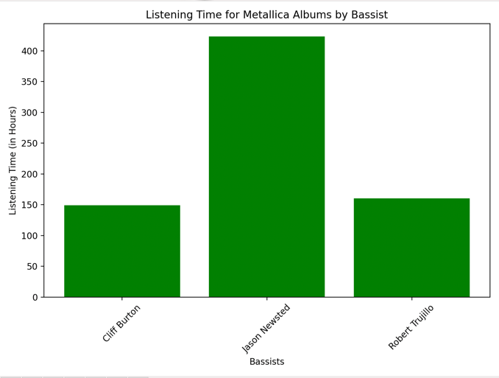

Other than these as a person who loves concert tracks. I have detected percentage of listening live songs and total minutes of for main four big concerts.

ekran görüntüsü, metin, diyagram, yazı tipi içeren bir resim

Açıklama otomatik olarak oluşturulduekran görüntüsü, diyagram, öykü gelişim çizgisi; kumpas; grafiğini çıkarma, metin içeren bir resim

Açıklama otomatik olarak oluşturuldu

After these graphs, we can go back to my hypothesis. As we have seen on the graphs, I have listened to Black Album and other popular culture albums so much. At the end, it is seen that popular culture songs have a domination on thrash metal.

ekran görüntüsü, metin, diyagram, yazı tipi içeren bir resim

Açıklama otomatik olarak oluşturuldu

As a result, we can say that even though I am a true fan of Metallica, I have listened to songs that are more known in worldwide more than thrash songs. This demonstrates that a popular culture item is not bad just because everyone loves that. To the contrary, this fact is a clue that the item is something good as much as everyone have a chance to love it.

metin, ekran görüntüsü, grafik tasarım, kolaj içeren bir resim

Açıklama otomatik olarak oluşturuldu

Lastly let’s talk about my machine learning algorithm. I focused on a suggestion AI in a basic way. I have created another genre type that is independent form album’s genres. It is a separation between individual emotional songs and politic protest songs. After that I also analyzed my result for that created and algorithm.

ekran görüntüsü, metin, diyagram, yazı tipi içeren bir resim

Açıklama otomatik olarak oluşturuldu

My algorithm takes a song and decides the next suggestions’ way. From the same genre, or from the same emotion. Mostly it gives a political suggestion if song is political, and individual suggestion if song is individual, this odd is ¾. In the possibility ¼

New song is suggested from the album that current song is found. I have a detailed explanation how algorithm work. But here is my example for algorithm results. I want to add that only the first song is suggested from “Fade to Black”. Other songs are suggestion of the song before them.

metin, ekran görüntüsü, yazı tipi içeren bir resim

Açıklama otomatik olarak oluşturuldu

**Conclusion**

I definitely can say that it was really fun to make this project since it was about one my hobbies. Also, I want to improve some things in this project as my skills of data science increase. For instance, I can use better charts, especially better than pie chart, and I want to create a better and more complex algorithm, for suggestion of songs. I tried to create a decision tree with the help of ChatGPT but I could not manage to do it. I want to improve those things in the future. Finally thank you for reading my report, I hope you like it and have fun as much as me.